Practical 4
Definition : Merge two datasets using Pandas and create a pivot table showing total sales by category.
Outcomes / Learning : I've learned how to merge two separate DataFrames in Pandas based on a common key, in this case, the 'EmployeeID'.
I also learned how to create a pivot table to summarize and analyze data, specifically to calculate the total sales per category for each employee.
Working

Required Tool : The Experiment was performed using a Python Environment using Pandas Library, a Standard tool for Data Analysis.

Working : The program successfully merges the employee and sales data using a shared EmployeeID.
It then generates a clean pivot table, effectively showing the total sales made by each employee, broken down by product category.

Step 1 : Importing The Pandas Library to Import Both the Files on Which The Experiment needs to be performed on using the .read_csv() function.
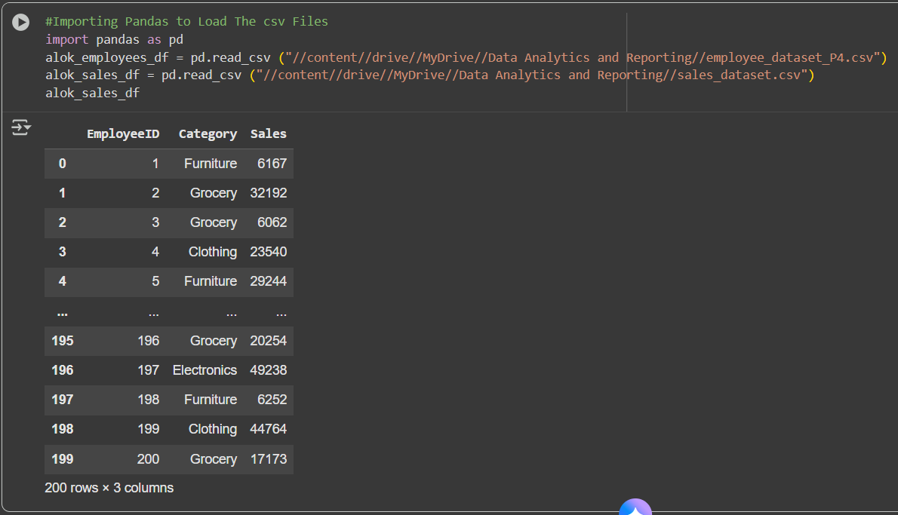
Step 2 : Merge the two dataframes on the common column 'EmployeeID' because the EmployeeID column is present in both the employees and sales dataframes, making it the perfect key for the merge operation. 'inner' is used to keep only the rows where EmployeeID is present in both dataframes.
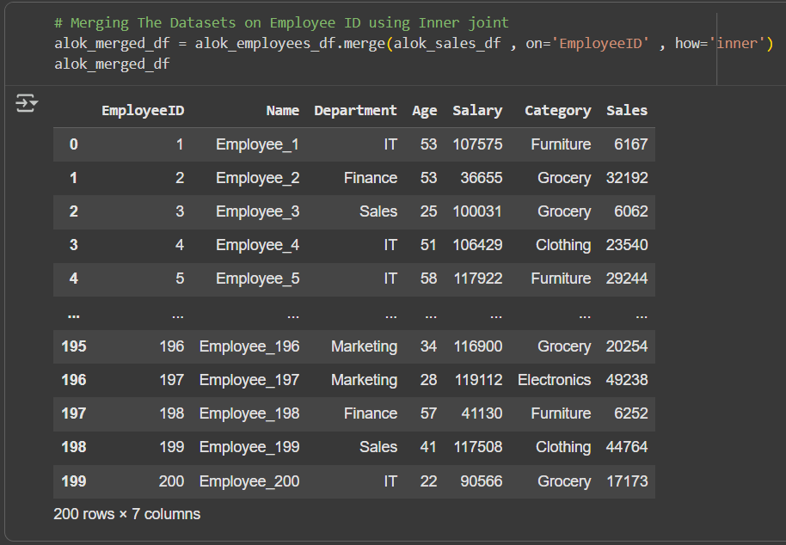

Step 3 : While Creating a pivot table from the merged dataframe, The index is set to 'Name' to show each employee's sales, The columns are set to 'Category' to break down sales by product category, The values are set to 'Sales' to sum up the sales figures for each category and The aggregation function 'sum' is used to calculate the total sales for each combination. 